Consider the following figure for TCP congestion control:

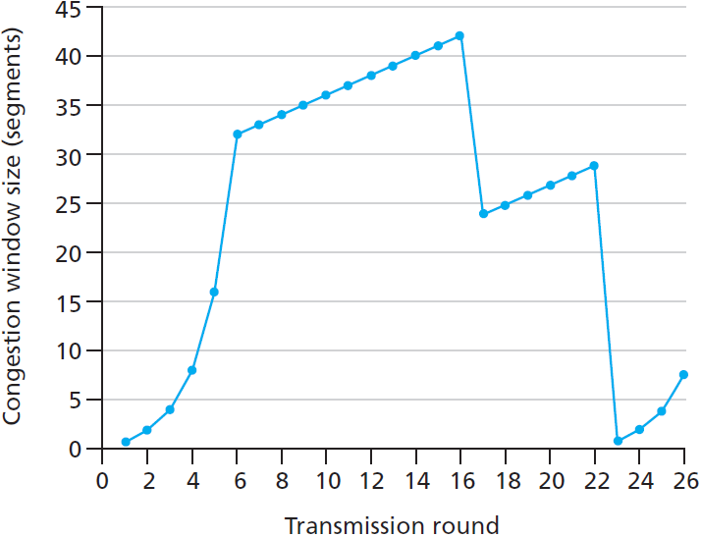

What would the ssthresh and cwnd be in the 11th transmission round if a packet loss due to timeout is detected in the 10th transmission round? What if 3 duplicate ACKs are detected? Answer in both cases of Tahoe and Reno congestion control schemes.